**The parallel kingdoms of the United Nations Agencies and some foreign missions are behind the failures and disputed election in Afghanistan**

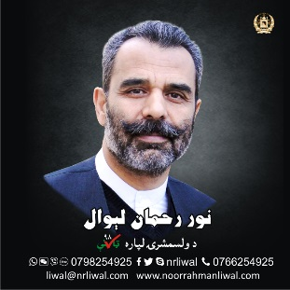

**Noor Rahman Liwal,** 6 July 2019

We understand and appreciate the moral work of United Nations (UN), their humanitarian activities and the convention on the privileges and immunities of the UN. Also, we value the sacrifices of the allies of Afghanistan who pay, train, gather, elect/select and even kill Afghans and their own children for the benefit of Afghans!

In Afghanistan, the misappropriation of relief fund is widespread due to lack of accountability reaching a level that needs the world’s attention, as a result, unfortunately, the UN and some foreign missions are operating as parallel kingdoms in Afghanistan, without any fear of morality, responsibility or accountability which has placed Afghanistan at the top of the global corruption index and the 1st as the most insecure country.

As a presidential candidate I would like to present my own experience of the past 6 months in the form of a case study to enable us all to take measures for improvements of the situation to first benefit Afghans and then humanity at large and end the Afghan dilemma of unfortunate and painful tragedies.

On 3rd February 2019 I sent a letter, to Mr. Tadamichi Yamamoto, Special Representative of the Secretary-General and head of the United Nations Assistance Mission in Afghanistan (UNAMA), sharing with him, considered views, articles, solutions and recommendations for a credible, free and transparent Afghanistan presidential election 2019, more information can be found in my website www.noorrahmanliwal.com/tkk. We draw their attention that without cost, we offer the Independent Election Commission of Afghanistan (IECA or election commission) a blockchain enabled system developed by us in Afghanistan, that can provide accurate voting and voter registration, based on biometrics of Face and Finger Print recognition.

Also highlighting, that while I, was running for the 2014 presidential election, unfortunately the then commission declared me unqualified without logical and legal reasons. Since then we have been working to develop a smart ICT based e-governance solution that can help boost the management and delivery of public services in Afghanistan at the capacity of 35% presently to 90% in the third year of our presidential system. The system will significantly bring down the level of systematic corruption that killed and hurt millions of Afghanistan and non-Afghans alike.

Therefore, we invited Mr. Tadamichi Yamamoto and or the technical team involved in election 2019 for a thorough discussion on the above mentioned points and sought cooperation for a free and fair election in Afghanistan. We never heard back, which shows lack of a sense of responsibility, transparency and answerable employees of UN acting like absolute kings.

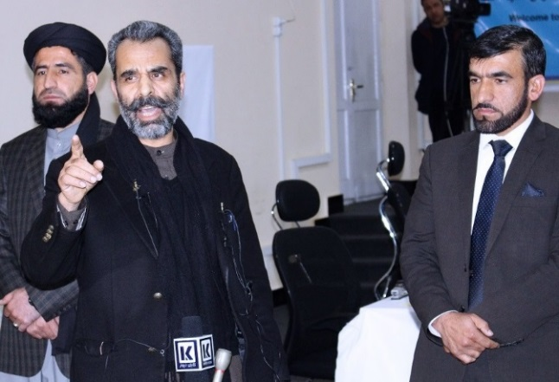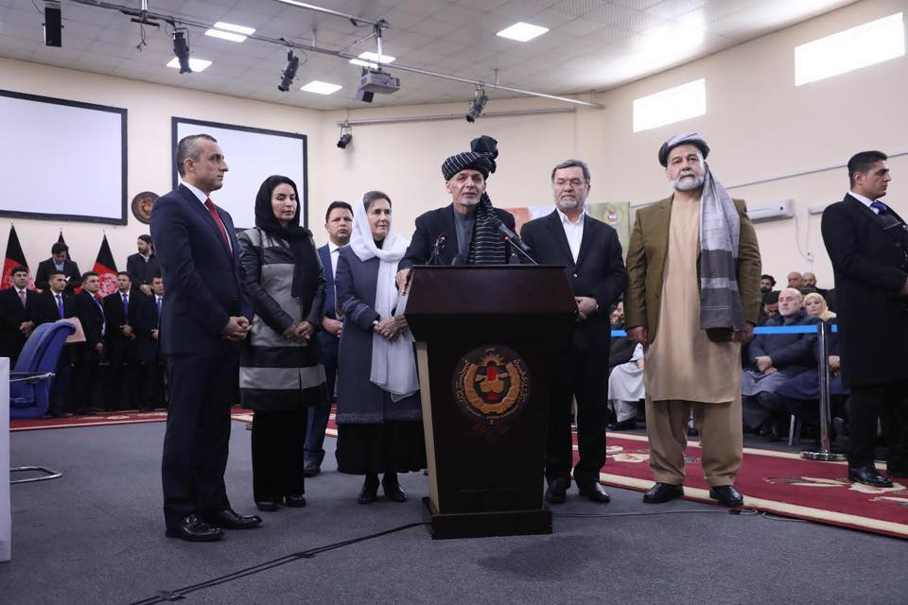Many may ask why we were asking UNAMA for a meeting? firstly, UNAMA was getting involved openly in the politics of Afghanistan beyond its mandate, secondly, we got internal information from election commission that UNAMA’s Non-Afghan consultants were, secretly listening, watching, recording and spying on every move of my registration as presidential nominee on 20 January 2019.

Figure 1: Nomination Speech setting for Mr. Ashraf Ghani in Election Commission on the same day and same location.

Figure 2: Nomination Speech setting for me in Election Commission.

Under their noses, during the registration, discrimination was at full swing as every candidate was treated differently in the same location during the same day and hours. Thirdly, amazing are the messages King Yamamoto is sending to the media, the candidates and the Afghan nation to participate in the every steps of election, portraying himself as the number one person in Afghanistan, although he should have used the relevant authority like the election commission for such messages, many Afghans employed at the election commission told me that as long as UN is paying for election, candidate of their choice will be selected not elected.

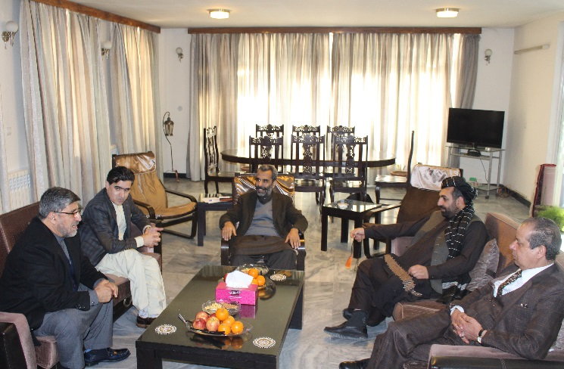Some of the embassies and missions are calling on presidential candidates to visit their parallel kingdoms and present their programs, without respecting any protocol, they act like this, because they pay a few bucks for the elections, merrily not to support the elections but open doors for their interference in the process. On 3rd February 2019, I received a call from a gentleman calling himself, an Afghan & Political Advisor, European Union (EU), he said, we are working on a program for all Afghan presidential candidates to come and present their program to diplomates of European countries. We told him the program is unique and may not be diplomatically or politically correct for EU to carryout and it may further damage the already fragile elections process and in view of public it may puppetize coming Leadership for the success of which EU was contributing generously.

Figure 3Figure 3: The Presidential Candidates Jirga members, having meeting at the office of Liwal (Jirga.org)

This call reminded me that I should resume my program “Awakening & Reconciliation from An Afghan Perspective”, planning to visit centers of European politics in Bonn, London, Paris and Brussels. While considering Europeans as natural allies of Afghanistan; who finance, train, trying to elect/select and even kill Afghans and their own children for the benefit of Afghans! Are we not asking, or are they not concerned, what Afghans want? Are Afghans thankful or critical of them; do Afghans consider the on-going efforts helpful or challenging enough to be considered an act of an enemy? More information visit <https://www.noorrahmanliwal.com/wh>.

Like UNAMA, we draw the attention of the European Union in Afghanistan to, offers, articles, solutions and recommendations for a credible, free and transparent Afghan presidential election 2019, especially, our free offer of voter’s registration, voting, result counting and monitoring. Also, under Liwal Good Governance Program, an e-governance solution that can help boost the management and delivery of public services in Afghanistan which is presently manual, full of corruption and bureaucracy. Liwal Good Governance Program utilizes open governance standards, which will significantly reduce corruption. We also offer cooperation on the launch of an Open Government Portal that will list governmental and non-governmental initiatives at the village level and offer for listing EU contributions. Inviting delegation members, especially those interested in Presidential Election 2019, we never hear back.

To know the quality of diplomats’ engagement in Afghanistan, on 2 April 2019, a Jirga consist of seven presidential candidates, with objective and programs for peace in Afghanistan. 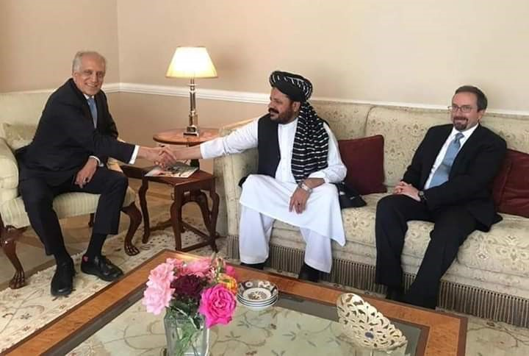The Jirga offered mediation among involved parties, the Afghan Government, The Taliban and the United States + NATO. The Jirga sent a letter with phone call follow-ups to Mr. Zalmay Khalilzad, U.S. Special Representative for Afghanistan Peace and Reconciliation, however, we never heard back, but at the same time and on the same matter, top US diplomats were having a fun time with very low-ranking advisors to a candidate discussing peace efforts.

Figure 4Figure 4: Top US diplomats having fun time with very low-ranking advisor to a candidate discussing peace in Afghanistan, while having no time to respond or meet 7 presidential candidates on the same matter (Jirga.org).

No wonder the Americans and the Afghans are stuck in the longest war of their histories with numerous of invaluable lives lost from both sides. The engagement and planning of such calibers could be the reasons behind the proxy war going on, as retired Brig. Gen. Donald Bolduc explained it “the entire war is a story of one mistake after another, putting success or “victory” as we typically define it further out of reach. U.S. military tactical level units have performed admirably, but political leaders, policy makers, and senior general officers inside and outside of Washington have failed them… imposing American-imposed solutions to Afghanistan’s problems, we disincentive the Afghans from leading and chose to ignore thousands of years of history.”

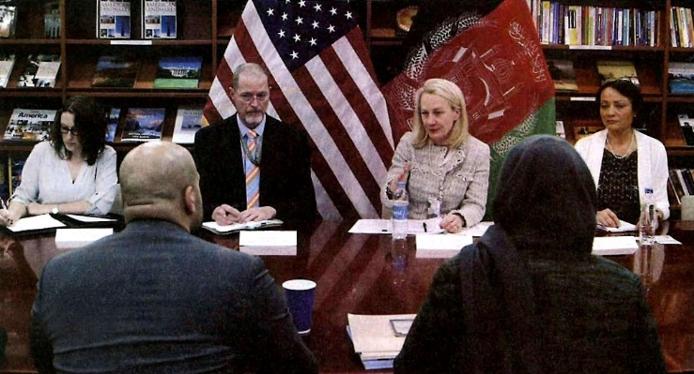The Americans are openly interfering in the Afghan election matters. On 20th May 2019, Ms. Alice Wills, Acting Assistant Secretary of State, met with election commission members and dictated to them, suspension of Provincials Shura’s (Counsels) and Ghazni province parliamentary elections. She said concentrate all efforts on presidential elections only. Without consulting the stakeholders, the next day the election commission announced only presidential election.

Figure 5Figure 5: Ms. Alice Wills meeting with Afghan election commission members.

On 24th April 2019, UNAMA sent an invitation titled “Presidential candidates and leaders of political parties and Civil Society to a meeting with the Election Support Group to discuss key issues around elections “, without a detailed Agenda, what were the key issues? We told the caller that the Jirga of 7 presidential candidates will not participate in such a sundry meeting of diverse groups with very limited time for each participant to express himself in as little as 2 minutes or less. We recommended that UNAMA arrange specific meetings with each stakeholder group having enough time for each meeting and for conclusion, arrange a final gathering consisting of all stakeholders. UNAMA, once again, completely ignored, and did not even bother to share the minutes of the meeting with the stakeholders and participants.

UNAMA’s is arranging such unorganized and short meetings of diverse people for confusion and dictating the hidden agendas of corruption and nepotism without considering the views of the participants, if this was not the case, UNAMA would have certainly shared the minutes of the meeting with stakeholders and participants. We realized that these meetings are only organized to find evidence and justification for the funding sources, just to show that whatever UNAMA is doing is done in consultation with stakeholders. Therefore, the results speak for themselves, politically engineered, failed and controversial elections, which UNAMA has been facilitating in Afghanistan for the past two decades.

In that meeting of 24 April, 2019 it was dictated to the election commission and candidates that Afghanistan cannot use biometric in the presidential elections, although the system and equipment are already purchased during the last Parliament election by a presidential decree No.51 dated 22/5/1397, under which National Statistic and Information Authority (NSIA) with Joint Technical Committee, comprising of the Minister of Finance, Minister of Communication and Information Technology and Directors of NPA, NISA. Smart Verification Terminal (SVT3000SE), Voter Application for Face and Fingerprint on Device offline and online (Fingerprint SDK and Face SDK) with local Identification System, including License per device, Application development/customization and training was purchased as a single source from a German company called Dermalog, under the decree No. 66, costing 14.65 million Euro, additional human resources and other costing 33.2 million US$. The contract was full of corruption and procurement irregularities as $200 Terminals were purchased for above $1500. The first mistake was to give the professional work of electoral body to NSIA having no technical or managerial experience in election and biometric. Secondly, the joint technical committee also had no experience. Thirdly, the purchase was just made a few days before the elections, many of the election staff did not know how to use the devices or applications to the point that the collected data was not even integrated with the central system. Another discrimination was in the interface and documentation of Application, it totally missed national language Pashto, under nepotism the election commission staff hired were mostly ethnic minorities who could not understood the language of majority Pashto on the voting day.

We offered a free localized biometric solution for the Afghan presidential election, informing EU, UNAMA and election commission and government, either intentionally or unintentionally they ignore such offers to kill local initiatives, because these solutions can solve local problems and shut ways for possible abuse of fund spent on luxuries of UN and related bodies, in the 90’s I was working with the UN operation in Afghanistan, I found that 75% of all the budget was spent on luxuries of UN employees around 20% waste in corruption and 5% were reaching the beneficiaries. I resigned and started my own business. Currently, the UN project are even printing election stationary outside of Afghanistan and importing them back to Afghanistan, during Wlosi Jirga election, few pages were missing, where dozens of candidate’s names could not be found to vote them, if justification is non-availabilities of local expertise, then even that is a big fat lie and proof of corruption.

On 26th June 2019 I went to perform the voter registration top-up processes that ended on the 29th of June. The registrar could not find my name in the voter list even though my voting sticker was made inside the Election Commission. Instead of having a connection to the database and correcting that sticker in the system, they manually attached another sticker on my identification documents. As a leading IT expert, I know even a teenager can develop a database and an app on smartphones to register or update the stickers, but those who developed the registration system cannot. Another presidential candidate reported the same situation, if the UN supported system of registration is unable to properly register presidential candidates, how can they do it for the rest of the voters? The registration process by UNAMA and UN Electoral Support Project (UNESP) is politically engineered for opening doors to another shameful election like the last one, these projects are full of nepotism, even staff members who were deported as persona non grata in previous governments are rehired and working again, another person who was repelled from her country due to fraud in election, she is reported to be working in UN electoral project for Afghanistan.

Figure 6: Mr. Noor Rahman Liwal, Presidential Candidate, visiting the voter top-up center in Kabul registration

On 25 June 2019, the Election Commission decided that they will go for unprofessional use of biometric, where no one is registered as biometric voters, yet hardware devices will be purchased under UNAMA coordination or from national budget. It is amazing that officials from the German company Dermalog could not visit Afghanistan and IEAC Staff could not understand Automated Biometric identification System (ABIS) from documentation, emails, messaging, phone and video conferences, therefore, Election Commission prepared a big delegation that comprised of dozen, of commissioners and dozens of other staff members to visit Dubai to talk to Dermalog. It is surprising to learn that during voter registration, no one was registered biometrically, yet, the Election Commission delegations, two main demands from Dermalog were: Prepare biometric voters list and attach the sticker number to the biometric of voters in the system. This is the main dilemma and a door for engineered voting and resulting counting. We understand the ABIS software may have been licensed from a single source, but there are thousands of companies offering biometric hardware devices for under $200 that are purchased above 1500$ each without any transparency of procurement process!

On June 10, 2019, I called UNAMA and told him that we have documents showing that during the past election of the Wolesi Jirga, out of dozens of activities which were promised to election commission under the UNAMA coordination by UNESP, only 3 were carried out with inordinate delays and full of corruption, which led to the crisis in the election, a crying shame for all. We tried to reach the responsible people in UNESP to have their views, without any success. When we asked relevant advisors to give us the contact of the UNESP responsible people, while confirming UNAMA as coordination body of the electoral support that include UNESP, for some reason they could not give the contact information, and there was no contact information on UNESP website either. They promised us that they will convey the message, and someone will get back to us, nobody contacted us, now imagine if a presidential candidate cannot reach or get response, how can other Afghans? There is irresponsibility and no accountability, therefore, some people are utilizing immunities of UN against its mandate. We sent letters to his excellency Secretary General and other relevant bodies, requesting them to work for the improvement of the situation.

On June 25, UNAMA, sent another surprise invitation again without detailed agenda, titled “Election Support Group Ambassadors comprising the European Union, NATO and the Governments of Australia, Sweden (on behalf of the Nordic plus), Germany, Japan, the United Kingdom and the United States of America”. This time asking specifically to invite one of my running mates to a meeting. A gentleman from UNAMA was kind enough to call us again and again, asking who is joining from our team? As a joke, I told him why not invite both of my vice-presidents to the meeting, because we are the only unlucky country having two?’ He replied with no, no, UNAMA invited one from all candidates and finally, I told him that we are not participating, and I will write about it.

Warlords are the most favorite commodities in the current Afghanistan politics, under the democracy classification index, achievement of the last 18 years in Afghanistan is an Authoritarian regime not yet even near to the Flawed Democracy the United States is currently experiencing, let alone full democracy which few European countries are achieving. If Afghanistan is even moving towards Flawed Democracy, there are no other options but to correct the following core problems before Afghanistan presidential election 2019:

1- FIXING LEGALITY OF THE CURRENT ILLEGAL GOVERNMENT

The Current unconstitutional, illegal coalition and corrupt government of two candidates Mr. Ghani and Mr. Abdullah is not capable to manage an acceptable election. Therefore, an impartial caretaker government is urgently needed to hold a free, fair and transparent presidential election, the result of which will be acceptable to all. The viable option is an inter presidential candidates’ election, voting one of them as the caretaker president and remaining candidates forming a supervision board to oversee the caretaker president during government, election and transfer of power. If anyone is not supporting this option, then indeed they are benefiting from the war, corruption and engineered elections. The caretaker will also provide an opportunity for Taliban to join the election and we can reach peace, remember Taliban cannot reach an agreement with present expired Afghan Unity Government of Mr. Ghani or the Doha talks under the shadow of Mr.Karzai and company.

2-TECHNICALLY FIXING THE ELECTION COMMISSION VOTING PROCEDURES ESPECIALLY THE RESULT COUNTING.

To have a relatively credible Afghanistan Presidential Elections 2019, there is no other option but to have all three phases of voter registration, voter identification and results counting completed using modern technologies of biometric and blockchain. We will be happy to work with all stakeholders to facilitate that. Unless all processes of the election are biometrically enabled, an early election in hurry, following the present timetable will further destabilize Afghanistan, the world and will be a shame and catastrophe for all of us and waste of resources.

3-HANDING OVER BUDGET AND RESPONSIBLY TO THOSE WHO CAN BE HELD ACCOUNTABLE

We recommend to the Afghanistan Election Support Group, to make the entire process an Afghan led, and Afghan owned, so that we have a single body responsible and accountable, else stop your support, let Afghanistan find their own resources. In the present situation the immunities of UN and especially corruption, bureaucracy and nepotism in UNESP and other stakeholders is making the process complicated, irresponsible and corrupt, where no one can be made responsible and accountable.

4-MAKE ELECTION COMMISSION FREE AND RESPONSIBLE

It was considered a big achievement in the eyes of the Afghan public when the commissioners of election commissions were openly selected in a transparent manner by voting of 17 presidential candidates, but soon after that the illegal government of Dr. Ashraf Ghani, blackmailed them, most of the commissioners told us, government official warn them to follow the quarantine, must meet government official but cannot met with presidential candidates else they will face the faith of x-commissioners. It is astonishing, all the electoral results of x-election commissions are accepted, but all the commissioners are illegally terminated and currently under politically motivated legal prosecution. On 28 April, 12 presidential candidates and political parties, appointed me as head of the committee consisting of technical member from the group, to help the commission and candidates clearly understand and agree on the technicality of the election commission, specially IT and biometric systems, we sent a formal request to the election commission for technical evaluation, since then promising, but not arranging the tour. We have information that the current result tabulation system at commission is a total fraud, it needs fixing before the presidential elections. We need a more transparent system, that every step is clearly understood by the candidates and nothing should be concealed.

In this writing, I may seem pessimistic but the situation in Afghanistan which is adding to the suffering of millions of Afghans and other people around the world may not improve if we do not change the attitude of those employed by the UN and other allies to work for improvements, respect local initiatives and stop imposing alien ideas, otherwise the Afghan war and suffering will continue and very few will enjoy their mini-kingdoms. A big change is needed else more innocent lives will be lost.

I hope our observations, experiences and findings will bring changes that will truly reflect the mandate of all UN member states whose taxpayer money pay the very existence of the UN and the humanitarian activities of the United Nations, across the world. We hope the arrogant western diplomats will change their attitude and policies, keep in view our thousands of years of history not only governing ourselves but the entire Indian subcontinent.

Last but not the least, I cannot emphasize enough the imperative of the pressing need of the establishment of a caretaker government for the sake of just, free and transparent presidential election. Also adding the caretaker government to the constitution is vitally important for the checks and balances of the future Afghan governments, national security and prosperity of our motherland.

**Mr. Noor Rahman Liwal, Afghanistan Presidential Candidate 2019 and Presidential Nominee 2014, an Afghan philanthropist, entrepreneur, inventor, leading IT expert and businessman, owner of multi-national companies, Pashto TV, worked with governments, Mujahideen, United Nations Agencies and NGOs, can be reached at noorrahmanliwal.com and @nrliwal.**