Liwal Stock Clearance Sales

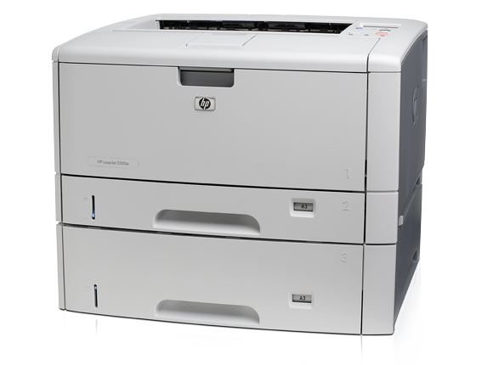
S.  No. | Item | Description & Details | Unit | QTY | Unit Price in US$ | Total Amount US$
1 |  | Q7545A#BB6 HP Laser Jet 5200tn Printer /Mid East | Each | 1 | 2,494.77 | 2,494.77
2 |  | C4129X HP LJ 5000/5100 Black print cartridge (10,000 pages) | Each | 1 | 137.34 | 137.34
 | Total Amount in US$ |  |  |  |  | 2,632.11

Tel: 0799-203534
Tel: 0700-281309

